**Experiment 8**

**Student Name: Sahul Kumar Parida UID: 20BCS4919**

**Branch: CSE Section/Group: WM-904/B**

**Semester: 5th Date of Performance: 08/11/2022**

**Subject Name: Web and Mobile Security Lab**

**Subject Code: 20CSP-333**

**Aim:**

Write a program to sign and verify a document using DSA algorithm.

**Software/Hardware Requirements:**

Windows 7 and above version.

**Tools to be used:**

1. Eclipse IDE
2. JDK (Java Development kit)
3. IntelliJ IDEA

**Steps/Method/Code:**

**import** java.io.*; //input the file data to be signed

**import** java.security.*; //provides methods for signing the data

**public** **class** GenerateDigitalSignature

{

**public** **static** **void** main(String args[])

{

/* Generate a DSA signature */

**if** (args.length != 1)

{

System.out.println("Usage: nameOfFileToSign");

}

**else** **try**

{

// the rest of the code goes here

}

**catch** (Exception e)

{

System.err.println("Caught exception " + e.toString());

}

}

}

**VerifyDigitalSignature.java**

**import** java.io.*;

**import** java.security.*;

**import** java.security.spec.*;

**public** **class** VerifyDigitalSignature

{

**public** **static** **void** main(String args[])

{

/* Verify a DSA signature */

**if** (args.length != 3) {

System.out.println("Usage: VerifyDigitalSignature " +"publickeyfile signaturefile " + "datafile");

}

**else** **try**

{

// the rest of the code goes here

}

**catch** (Exception e)

{

System.err.println("Caught exception " + e.toString());

}

}

}

**Output:**

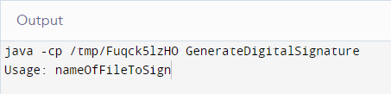

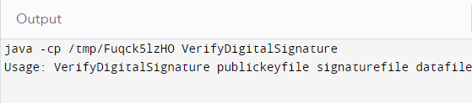

**Learning Outcomes:**

With this, you have understood the importance of asymmetric cryptography, the working of digital signatures, the functionality of DSA, the steps involved in the signature verification, and its advantages over similar counterparts.